**SE ASSIGNMENT 01**

**SUBMITTED BY: AYESHA ZIA(20K-0414)**

**QUESTION 01**

**Q1: Working on your proposed project, you have to do the following tasks**:

**a) Define your project.**

Our project consists of an E-commerce website that will consist of different categories of clothing such as winter and summer collections. It will have two different views one is for customers and the other one is for admin. Admin can add, delete and view products, they can also update the information of a particular product. The project will have a context API that stores the state of the cart when customers navigate to different pages of the website. The customer can safely view the products, add them to the cart, and view their total bill.

**b) Define the goals and objectives of your project.**

Our main aim and objective of building this e-commerce website is to provide a safer means of online purchasing, minimizing the need for physical presence and wasting time in long queues in the malls. Our website will provide customers with access to a broader range of products and services than they could find in a physical store, increasing the chance of finding the exact product they need. The main goal of this website is that our customers can use this platform for online shopping through their smartphones as well and they no longer need any desktop or pc to access this shopping store. Thus it provides a convenient, easy, and faster way to purchase different products by browsing their desired product.

**c) Scope of your work.**

Below are some of the important task that needs to be done in order to make this website fully functional

* The admin portal should be fully functional and the admin should be able to add, view, and delete products easily
* Admin can view all the transactions through the database
* Admin can view the order details of each customer
* The sign-up and login data should be safely stored in a database so that customers can easily log-in
* The admin sign-up contains only one verified account through which the admin will enter the application.
* The customer can add items to cart and view their total bill.
* Customers can choose to pay the bill via credit card or cash on delivery.
* Once the customer completes his/her order, the order details will be stored in the database .
* The admin will immediately confirm the order that is paid via credit card but order for COD will remain pending until delivered.

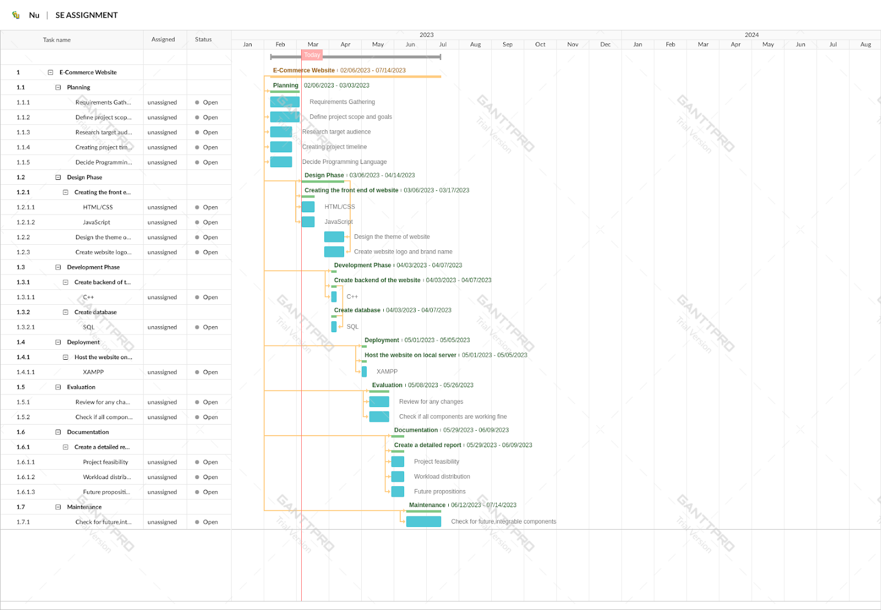**d) Create a Work Breakdown Structure as per your requirements. [4 Marks]**

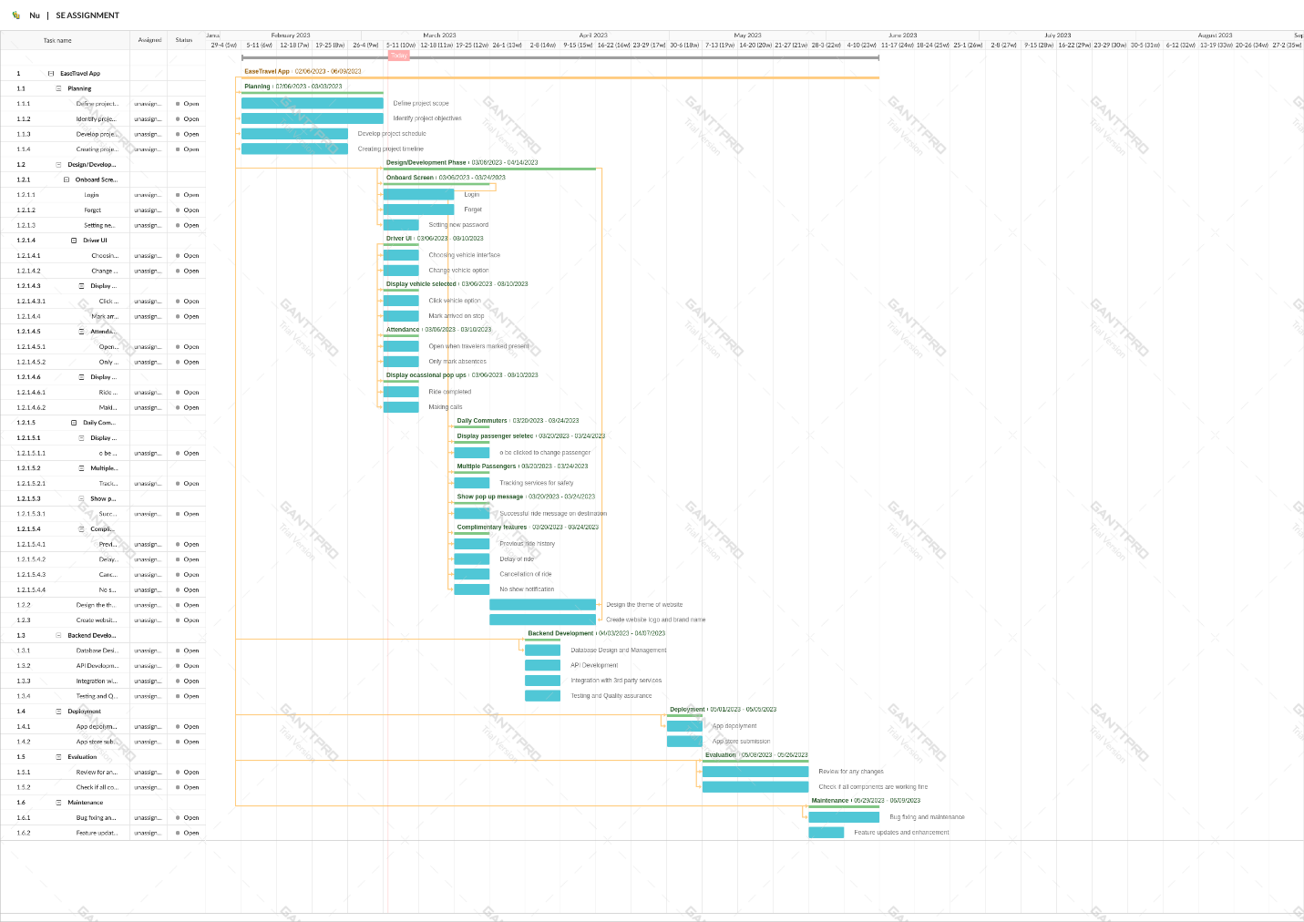**QUESTION 02**

**QUESTION 03**

**a)**

Weighted Estimate = (P + 4B + O) / 6

|  |  |  |  |  |
| --- | --- | --- | --- | --- |
| Estimators | Pessimist Effort | Optimistic Effort | Expected Effort | Weighted Estimate |
| Ali | 87 | 62 | 70 | (87 + 4(70) + 62) / 6 = 70.5 |
| Zain | 91 | 72 | 80 | (91 + 4(80) + 72) / 6 = 78.5 |
| Shan | 88 | 50 | 70 | (88 + 4(70) + 50) / 6 = 67 |
| Hassan | 97 | 88 | 95 | (97 + 4(95) + 88) / 6 = 91 |

**b)**

Average joint estimate=sum of all weighted estimates/no. of estimators

= (70.5 + 78.5 + 67 + 91) / 4

= 76.25

**c)**

Confidence Interval = Average Joint Estimate ± (1.96 xSD) where,

SD is the standard deviation of all the data

To find standard deviation, we will use this formula:

$$\frac{\sqrt{sum} of\left(weight of estimator\right)* (weighted estimate-avg.joint estimate)²}{no.of estimators-1}$$

After inserting the values we will get:

$$=\frac{√[(1 x (70.5 - 76.25)² + 1 x (78.5 - 76.25)² + 1 x (67 - 76.25)² + 1 x (91 - 76.25)²)}{4-1}$$

= $\frac{√[283.25}{3}$

=9.187

95% Confidence Interval = 76.25 ± (1.96 x 9.187)

= 76.25 ± 18.002

= [58.248, 94.252]